**Group 6 2ECE-B**

**REYES, John Emmanuel ECE 2112  
ZABALA, Jude Nico**

**MACHINE PROBLEM 3**

**CODE:**

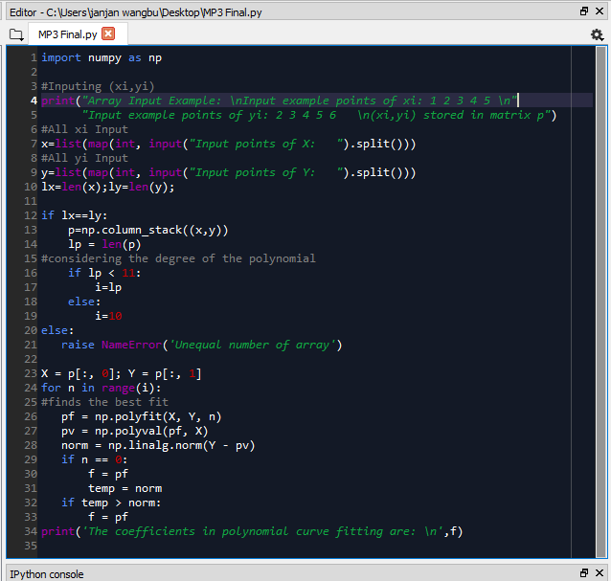

**SAMPLE OUTPUT:**

Trial 1:

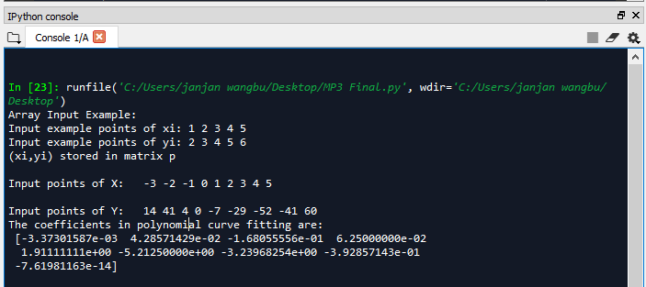

Trial 2:

